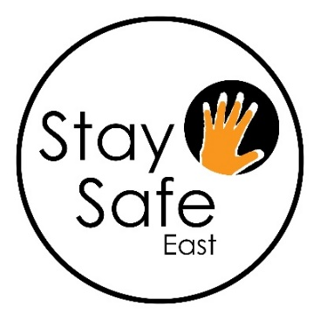
Stay Safe East
Supporting disabled survivors
is seeking an exceptional person to join us as our new
Finance Manager
We’re writing our next chapter. Be part of it!
Salary: £ 33,170 per annum pro-rata for 17.5 hours per week.

Stay Safe East is a unique organisation run by disabled people, supporting disabled survivors of domestic and sexual violence, hate crime and other abuse.
We are looking for a Finance Manager who will oversee the management of the Charity’s finances, prepare budgets and support the CEO and the Board with fundraising and liaison with funders.
The successful candidate will have:
- Two years or more related experience of financial management of a charity or a business
- Experience of preparing financial reports and managing budgets over £500,000 with multiple income sources Good knowledge of the charity sector and charitable funding and contracts
- An ability to work with colleagues accessibly and sensitively
- Excellent communication skills
- A commitment to Stay Safe East’s work and ethos
We particularly welcome applications from disabled people who reflect the diversity of London’s communities of faith, sexuality, culture, ethnicity and age.

To apply, please complete the attached application form and monitoring form, and return them no later than Monday January 30th at 12 noon by e-mail to: recruitment@staysafe-east.org.uk. Interviews: February 2nd and 3rd 2023. The interview panel will be a Senior Manager and our Treasurer
Please head your e-mail Finance Manager Application
Important: Please ensure you return the forms as a typed word document in 16 point, not as a PDF or handwritten document; this is so all forms are accessible to members of the interview panel.
For an accessible Word format of the pack or other formats: please e-mail recruitment@staysafe-east.org.uk or ring/text Jo 07908 092 132 or Ioana on 07477 617 461

